**SUMMER INTERNSHIP TRAINING REPORT**

***Submitted in partial fulfillment of the requirements for the award of the degree***

***Of***

**BACHELORS of TECHNOLOGY**

**(2022-2026)**

***In***

**MECHANICAL AND AUTOMATION**

***By:***

**SIMMI AGGARWAL**

**07001042022**

**SWATI SINGH**

**08401042022**

**TOSMI GOEL**

**08601042022**

***Guided by :-***



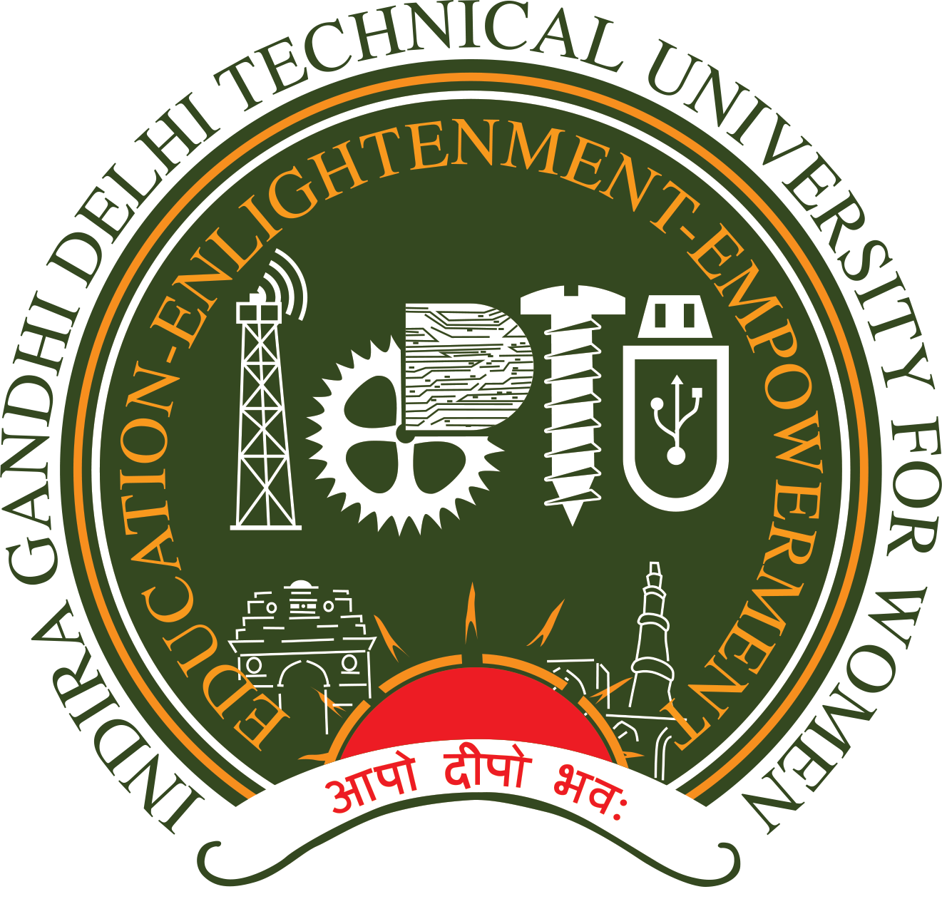

**UNDERTAKING REGARDING ANTI-PLAGIARISM**

We declare that the material/content presented in the report is free from plagiarism and is properly cited and written in our own words. In case plagiarism is detected at any stage, we shall be solely responsible for it.The members involved in this report making are mentioned below with their names along with their roll numbers.

**SIMMI AGGARWAL**

**(07001042022)**

**SWATI SINGH**

**(08401042022)**

**TOSMI GOEL**

**(08601042022)**

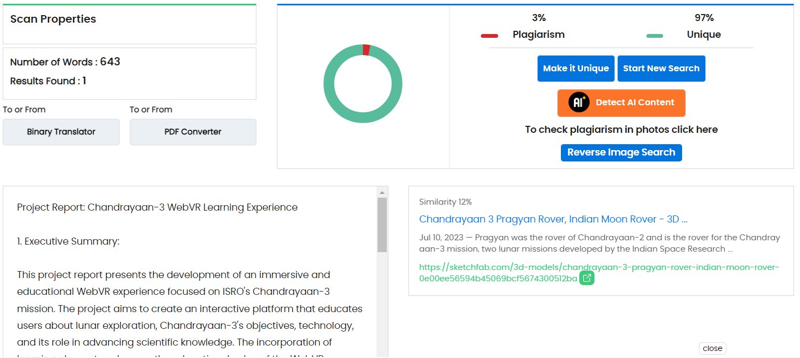

**ACKNOWLEDGEMENT**

It gives us immense pleasure to express our deep sense of gratitude to all those who have helped and guided us throughout the internship. We are deeply indebted to Ms. Ankur Thusu (Vice President, Finance & Accounting Department) for giving us the opportunity to work for and face challenges in order to grow professionally and personally. We also wish to express our gratitude to our mentor Mr. Saurabh Jain (Assistant Vice- President, Finance & Accounting Department )for his valuable suggestions and for sharing his vast reservoir of knowledge and experience during the entire duration of the internship. We were in the organization and it was a great learning experience and, as a curtain raiser to an exciting and rewarding career path. A very special thanks to all of our other colleagues at METAVERSE-VIRTUAL REALITY WITH UNITY, for giving us an excellent environment to work in, without their support it wouldn’t have been possible to create solutions. We would like to express our deepest thanks to our guide Dr. Gaurav Indra ,Assistant Professor for his valuable guidance, motivation, constant inspiration and above all for his ever-cooperating attitude that enabled us in bringing up this project work in the present form. Our heartfelt gratitude also goes to Dr. Amar K Mohapatra, Head of Department for providing us the opportunity to avail the excellent facilities and infrastructure. We are equally thankful to all other faculty members and non-teaching staff of the Information Technology Department for their guidance and support.

**SIMMI AGGARWAL**

**(07001042022)**

**SWATI SINGH**

**(08401042022)**

**TOSMI GOEL**

**(08601042022)**

**DECLARATION**

We the members of the group Verse-15, solemnly declare that the project report is based on our own work carried out during the six weeks of our internship training under the guidance and mentorship of the whole team of Steamedu Dr Rashmi, Mr Dharam Raj Panwar, Mr. Saurabh Jain, Assistant Vice President and internal guidance of Mr.Gaurav Indra, Assistant Professor, IGDTUW, Dr Alongbar Wary, faculty member of IGDTUW. We assert the statements made and conclusions drawn are an outcome of our research work. We further certify that:

I. The work contained in the report is original and has been done by us under the supervision of our supervisor.

II. The work has not been submitted to any other Institution for any other degree/diploma/certificate in this university or any other University of India or abroad.

III. We have followed the guidelines provided by the university in writing the report.

**SIMMI AGGARWAL**

**(07001042022)**

**SWATI SINGH**

**(08401042022)**

**TOSMI GOEL**

**(08601042022)**

**TABLE OF CONTENT**

UNDERTAKING REGARDING ANTI-PLAGIARISM………....2

ACKNOWLEDGEMENT………………………………………...3

DECLARATION………………………………………………….4

TABLE OF CONTENT…………………………………………...5

ABSTRACT/SUMMARY………………………………………...6

1. Executive Summary…………………………………………..7

2. Introduction…………………………………………………...7

3. Objectives……………………………………………………..7

4. Technical Implementation…………………………………….8

5. Learning Elements…………………………………………….9

6. Learning Impact……………………………………………...10

7. Challenges and Considerations………………………………10

8. Conclusion……………………………………………………10

9. Future Prospects………………………………………………11

10. Acknowledgments…………………………………………...11

11. References…………………………………………………...11

**ABSTRACT/SUMMARY**

This internship report explores the integration of metaverse and virtual reality (VR) technologies using Unity for the Chandrayaan-3 mission. The report outlines the metaverse concept's potential for enhanced public engagement and collaboration. It highlights Unity's role in creating immersive VR experiences and presents a VR simulation tailored to showcasing Chandrayaan-3's objectives for better public engagement. The report discusses challenges like hardware compatibility and scientific accuracy. The proposed integration is anticipated to elevate public interest, let users experience real time space voyage, and enhance scientific communication for Chandrayaan-3's success.

**Project Report:** **Chandrayaan-3 WebVR Learning Experience**

**1. Executive Summary:**

This project report presents the development of an immersive and educational WebVR(Web Virtual Reality) experience focused on ISRO's Chandrayaan-3 mission. The project aims to create an interactive platform that educates users about lunar exploration, Chandrayaan-3's objectives, technology, and its role in advancing scientific knowledge. The incorporation of learning elements enhances the educational value of the WebVR experience.

**2. Introduction:**

Chandrayaan-3, the upcoming lunar exploration mission by ISRO, serves as the inspiration for this WebVR project. The goal is to leverage cutting-edge WebVR technology to engage users in an informative and captivating exploration of the Chandrayaan-3 mission, while promoting space science and fostering curiosity.

**3. Objectives:**

The Chandrayaan-3 WebVR project's primary objectives are as follows:

- Develop an interactive and visually appealing WebVR environment that simulates the lunar landscape and spacecraft.

- Educate users about Chandrayaan-3's scientific goals, instrumentation, and technological innovations.

- Enhance learning through interactive elements, engaging simulations, and informational overlays.

- Spark interest in space science, technology, and exploration, particularly among students and enthusiasts.

**4. Technical Implementation:**

The technical implementation of the Chandrayaan-3 WebVR learning experience encompasses the following:

- WebVR Platform: Utilizing modern web technologies that support WebVR or WebXR for seamless cross-platform accessibility.

- 3D Models and Environments: Creating accurate and detailed 3D models of the Chandrayaan-3 spacecraft, lunar terrains, and related instruments.

- Interactive Learning: Incorporating interactive elements such as clickable annotations, pop-up information panels, and guided tours.

- Narration and Audio Guides: Integrating voiceovers and audio guides that offer detailed explanations and insights as users explore the virtual environment.

- Educational Modules: Structuring the experience into thematic modules focusing on objectives, technology, mission phases, and scientific discoveries.

**5. Learning Elements:**

The Chandrayaan-3 WebVR learning experience encompasses the following educational aspects:

- Scientific Objectives: Explaining the importance of lunar exploration, detailing Chandrayaan-3's mission objectives, including mineral composition analysis and geological studies.

- Technology Showcase: Providing in-depth information about the advanced instrumentation onboard the spacecraft and how they facilitate scientific investigations.

- Mission Phases: Guiding users through mission phases like launch, lunar orbit insertion, and descent, explaining their significance and challenges.

- Learning Pop-ups: Embedding interactive pop-ups that provide additional context, scientific facts, and mission-related trivia.

- Quiz and Assessment: Including a knowledge assessment section where users can participate in quizzes to test their understanding of the mission.

**6. Learning Impact:**

The Chandrayaan-3 WebVR learning experience aims to have a lasting impact by:

- Offering an engaging and immersive platform for users to comprehend complex scientific concepts.

- Catering to diverse learning styles through visual, auditory, and interactive content.

- Encouraging active exploration and discovery, fostering a sense of curiosity and wonder.

- Inspiring interest in STEM (Science, Technology, Engineering, and Mathematics) fields, especially among the younger generation.

**7. Challenges and Considerations:**

- Accessibility: Ensuring the WebVR experience is accessible on various devices, browsers, and internet speeds.

- Accuracy: Striving for scientific accuracy in the representation of spacecraft, lunar landscapes, and mission details.

- User Experience: Designing an intuitive and user-friendly interface that encourages engagement and exploration.

**8. Conclusion:**

The Chandrayaan-3 WebVR learning experience combines technology and education to deliver an immersive journey into lunar exploration. By providing users with an interactive and informative environment, the project aspires to contribute to science education, ignite curiosity, and create a memorable learning adventure centered around ISRO's Chandrayaan-3 mission.

**9. Future Prospects:**

Future developments could involve collaborating with educators to integrate the WebVR experience into educational curricula, expanding the content to include updates on the mission's progress, and enhancing user engagement through social sharing features.

**10. Acknowledgments:**

The project acknowledges the invaluable support from ISRO, which provided the necessary resources, mission details, and insights that contributed to the creation of this educational WebVR experience.

**11. References:**

A comprehensive list of references and resources used during the development of the Chandrayaan-3 WebVR learning experience.

<https://aframe.io/>

<https://www.isro.gov.in/Chandrayaan3.html>

This project report outlines the creation of a WebVR learning experience centered on Chandrayaan-3, designed to educate users through interactive exploration, scientific explanations, and engaging interactions. The project aims to bridge the gap between technology and education, fostering an appreciation for space science and inspiring future generations of scientists and explorers.